Adding widgets(containers, icon, buttons)

Workshop #3

Flutter Developer Bootcamp

# **Purpose**

This workshop demonstrates how to add widgets such as containers, icons and buttons.

# **Problem**

In the given workshop, there will be a blank image with report icon, breed name, nickname of pet and container which shows the owner name with blank image and posted date and brief Petstory. (This pet is 3 month old male cat. He has been at the shelter since he was born and we would really love to see him get in to a new home soon). You need to create three containers such as Age, Weight and Gender of pets(3 months ago, 4.3kg and Male or Female) and also add two buttons of chat and call option and give colors to the buttons.

# **How to Solve**

1. Checkout the workshop from Git Repo:

git clone -b <user-branch> <repo-URL>

2. Open the root folder inside VS Code

3. Execute the code by running command from the root: <full-command>

4. Add the given widgets by using several methods, widgets and functions.

5. Go To File: <specific-file-with-Widgets-method> à <method-name>, implement your Widgets creation logic.

**You will Achieve**

When you complete this workshop you will learn the following:

* **Containers**: Understanding how to utilize containers for layout and styling purposes.
* **App Bars**: Implementing app bars for navigation and actions within your Flutter app.
* **Circle Avatars**: Creating circular profile images or placeholders for user avatars.
* **Icons**: Integrating icons for visual representation and interaction.
* **Padding**: Adjusting spacing around widgets to improve layout aesthetics.
* **SizedBoxes**: Managing widget sizes and spacing within your app's layout.
* **Buttons**: Incorporating buttons for user interaction and navigation.
* **Text**: Displaying text content within your app.
* **Adjusting text alignment**: Controlling the alignment of text elements to enhance readability and design consistency.

# **Screenshots**

## **Before implementation (without specific widgets)**

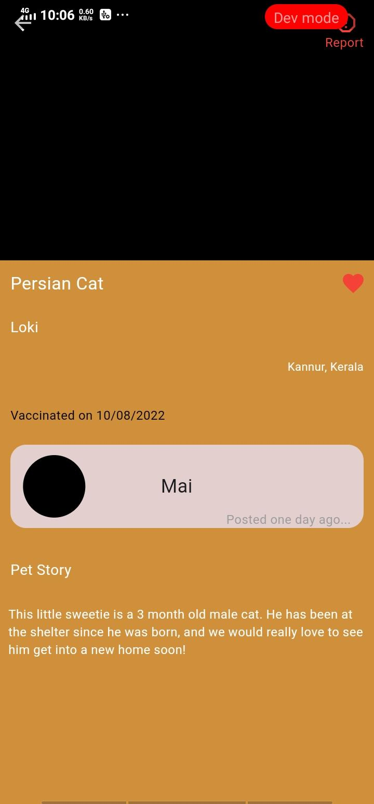

## **After implementation (With widgets)**

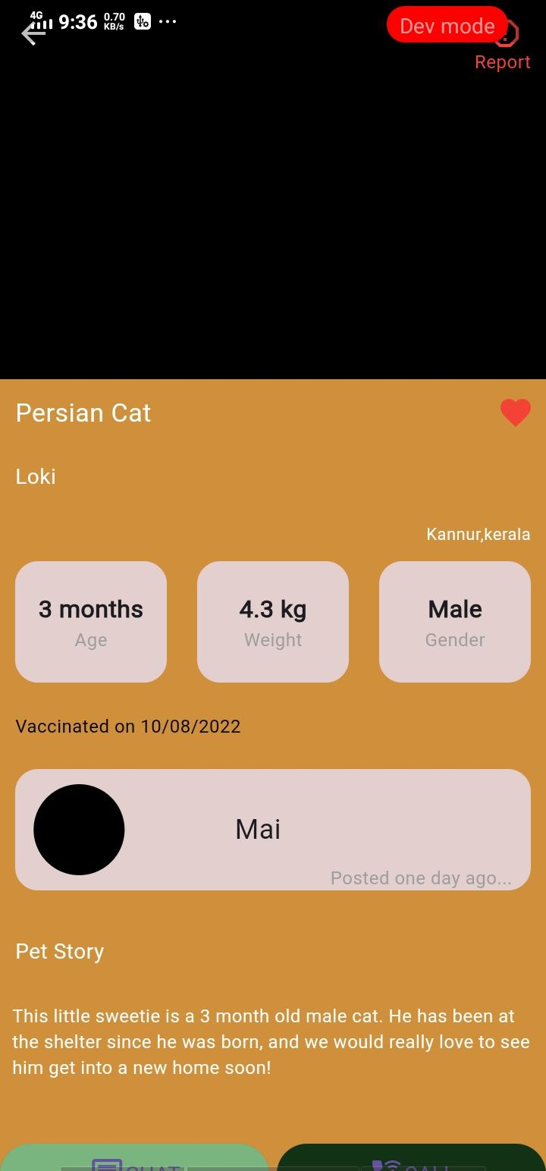

# **How to submit your workshop**

Push your project back to the same git branch using command:

<command name>

# **Happy Coding!**